Security-Enhanced IoT-Based Vehicle Access Monitoring System Forest Lawn Memorial Park
_______________________________________

A Capstone Project
Presented to the Faculty Members of the
College of Computing Studies, Information and Communication Technology
ISABELA STATE UNIVERSITY
Echague, Isabela
_______________________________________

In Partial Fulfillment of the
Requirements for the Degree
Bachelor of Science in Information Technology (BSIT)
With Specialization Track in Network Security
_______________________________________

By:
JAMEZDALE MARL B. BENIGNO

TABLE OF CONTENTS
CHAPTER I 5
THE PROBLEM AND ITS BACKGROUND 5
1.1 Introduction 5
1.2 Objectives of the Study 6
1.2.1 General Objective 6
1.2.2 Specific Objectives 6
1.3 Significance of the Study 7
1.3.1 Forest Lawn Memorial Park 7
1.3.2 Security Personnel 8
1.3.3 Administrators 8
1.3.4 Future Researchers and Developers 8
1.4 Scope and Limitations 8
1.4.1 Scope 8
1.4.2 Limitations 9
1.5 Definition of Terms 10
CHAPTER II 11
REVIEW OF RELATED LITERATURE AND STUDIES 11
2.1 Introduction 11
2.2 Review of Related Literature 12
2.3 Related Studies 18
2.4 Synthesis of the Reviewed Literature and Studies 21
CHAPTER III 23
RESEARCH METHODOLOGY 23
3.1 Research Design 23
3.2 System Development Method 24
3.2.1 Requirement Analysis 24
3.2.2 System Design 26
3.2.3 System Development 29
3.2.4 System Testing 31
3.3 Participants/Respondents 33
3.4 Data Gathering Instruments 33
3.5 Evaluation Procedure 33
3.6 Data Analysis Techniques 34
3.7 System Evaluation Criteria 34
CHAPTER IV 36
SYSTEM DESIGN, ARCHITECTURE, AND IMPLEMENTATION 36
4.1 Introduction 36
4.2 Network Architecture 36
4.2.1 Overview of Network Architecture 36
4.2.2 Network Components 37
4.2.3 Network Architecture Diagram 38
4.3 Application System Architecture 39
4.3.1 Overview 39
4.3.2 Components 39
4.3.3 Application Architecture Diagram 41
4.4 Data Flow Diagram 41
4.4.1 Overview 41
4.4.2 Data Flow Process 41
4.4.3 Data Stores 42
4.5 Security Framework 42
4.5.1 Overview 42
4.5.2 Security Mechanisms 42
4.5.3 Security Framework Diagram 43
4.6 RFID Device Development 43
4.6.1 Overview 43
4.6.2 Functionality 43
4.6.3 Reader Connectivity and API Validation 44
4.7 Security Testing and Evaluation 45
4.7.1 Tools Used 45
4.7.2 Testing Procedure 46
4.7.3 Metrics 46
4.8 Security Design Considerations 47
4.9 Prototype Implementation and System Interface 47
4.9.1 Authentication and Access Control 48
4.9.2 Gate Activity Monitoring 49
4.9.3 Records Management 51
4.9.4 RFID Credential Management 55
4.9.5 Audit and System Logging 60
4.10 Summary 62
References 66

CHAPTER I

THE PROBLEM AND ITS BACKGROUND

1.1 Introduction
Vehicle access monitoring plays a critical role in maintaining security, organization, and accountability in facilities where vehicles regularly enter and leave controlled premises. Manual recording through logbooks can require security personnel to write vehicle details, verify information, and later retrieve records when historical access information is needed. During busy periods, these activities can result in delays, incomplete entries, and inconsistent records.
The proposed study addresses these limitations through a Security-Enhanced IoT-Based Vehicle Access Monitoring System for Forest Lawn Memorial Park. The system uses an S4A UHF-202415 long-range RFID reader to automatically detect passive UHF RFID credentials assigned to vehicles. A Windows-based RFID Listener/Device Service receives the RFID detection and securely forwards the information to a Laravel/PHP web application through a REST API. MySQL provides centralized storage for vehicle, employee, visitor, RFID, access, audit, and system records.
The proposed system distinguishes permanent employee RFID stickers from temporary visitor RFID cards. Employee stickers remain assigned to registered employee vehicles, while visitor cards are assigned to valid visits and can be returned for reuse after checkout. The system therefore supports both continuous employee access monitoring and controlled temporary visitor access.
Security is incorporated throughout the system. Communication between the device service and the application is protected using HTTPS/TLS. Devices are authenticated before submitting RFID events, users are controlled through Role-Based Access Control (RBAC), passwords are securely hashed, incoming data is validated, excessive requests are rate-limited, and security-relevant activities are recorded through audit and system logs.

1.2 Objectives of the Study

1.2.1 General Objective
The study aims to develop a Security-Enhanced IoT-Based Vehicle Access Monitoring System for Forest Lawn Memorial Park using the S4A UHF-202415 RFID reader, RFID Listener/Device Service, Laravel/PHP, and MySQL to automate vehicle access monitoring while strengthening system security and traceability.

1.2.2 Specific Objectives
1) To design and develop an automated vehicle access monitoring system using the S4A UHF-202415 UHF RFID reader within a controlled network environment.
2) To implement permanent UHF RFID windshield stickers for registered employee vehicles and temporary UHF RFID cards for authorized visitors.
3) To develop an RFID Listener/Device Service that receives RFID detections and securely transmits normalized events to the Laravel application.
4) To implement secure communication using HTTPS/TLS to protect data transmission between the RFID device service and the application.
5) To implement device authentication using unique API credentials so that only registered RFID Listener/Device Service instances can submit RFID data.
6) To implement user authentication and Role-Based Access Control (RBAC) for administrators, security personnel, and viewers.
7) To implement secure data handling using password hashing, input validation, database constraints, and controlled database access.
8) To implement rate limiting and traffic filtering to reduce excessive or unauthorized requests and improve resistance to flooding attacks.
9) To implement audit logs, system logs, and security event recording for accountability, troubleshooting, and monitoring.
10) To conduct authorized security testing using tools such as Nmap, Wireshark, Metasploit, and Apache JMeter.
11) To evaluate the system's functionality, security, performance, reliability, RFID accuracy, and quality using ISO/IEC 25010, relevant ISO/IEC 27001 controls, and the CIA Triad.

1.3 Significance of the Study
This study will benefit the following:

1.3.1 Forest Lawn Memorial Park
The proposed system can improve vehicle monitoring efficiency, reduce dependence on manual recording, and provide centralized historical access records. Automated RFID identification can also support faster verification at the monitoring point.

1.3.2 Security Personnel
The system can simplify daily monitoring by automatically receiving RFID detections and presenting access decisions, current vehicle status, visitor information, and recent activity through a dashboard.

1.3.3 Administrators
The system can provide centralized management of users, employees, vehicles, visitors, RFID credentials, readers, reports, system settings, audit logs, and security events.

1.3.4 Future Researchers and Developers
The study can serve as a reference for future development of RFID and IoT-based monitoring systems that use a separate device service, web application, centralized database, and layered security controls.

1.4 Scope and Limitations

1.4.1 Scope
ï‚· The S4A UHF-202415 UHF RFID reader for passive long-range vehicle credential detection.
ï‚· Permanent UHF RFID windshield stickers assigned to employee vehicles.
ï‚· Temporary UHF RFID PVC cards assigned to authorized visitor visits.
ï‚· An RFID Listener/Device Service operating on a Windows PC or mini-PC.
ï‚· A Laravel/PHP web application and REST API.
ï‚· A MySQL database for centralized system records.
ï‚· Employee, visitor, vehicle, RFID credential, visitor visit, and reader management.
ï‚· Entry and exit monitoring, current vehicle status, access logs, audit logs, system logs, reports, and dashboard monitoring.
ï‚· User authentication and Role-Based Access Control for administrator, security personnel, and viewer roles.
ï‚· HTTPS/TLS, device authentication, input validation, rate limiting, logging, traffic filtering, and database security controls.

1.4.2 Limitations
ï‚· The initial implementation is focused on a controlled entry/exit monitoring point.
ï‚· The actual RFID detection distance and accuracy depend on reader configuration, tag placement, vehicle orientation, environmental conditions, and testing; the advertised reader range is not treated as the measured system result.
ï‚· The system requires network connectivity among the RFID reader, RFID Listener/Device Service, Laravel application, and database.
ï‚· Visitor RFID cards are temporary credentials and require proper assignment, checkout, return, and reuse management.
ï‚· Gate barrier control and CCTV integration are optional extensions and are not required for the core RFID monitoring function.
ï‚· Security testing is limited to authorized systems and controlled environments.

1.5 Definition of Terms
Term | Definition
RFID (Radio Frequency Identification) | A technology that identifies objects using radio-frequency communication.
UHF RFID | Ultra-High Frequency RFID used for longer-range passive tag identification.
RFID Windshield Sticker | A permanent passive UHF RFID credential attached to a registered employee vehicle.
RFID Card | A temporary passive UHF RFID credential assigned to an authorized visitor visit.
EPC (Electronic Product Code) | The identifier received from an RFID credential and used by the system to identify the credential.
RFID Listener/Device Service | A Windows-based service that communicates with the RFID reader, receives detections, and sends normalized RFID events to the Laravel application.
IoT (Internet of Things) | A system of connected physical devices that communicate with software services over a network.
RBAC (Role-Based Access Control) | A security mechanism that restricts system functions according to user roles.
TLS (Transport Layer Security) | A protocol used to protect information transmitted across a network.
API Key | A credential used by the RFID device service to authenticate with the application API.
Audit Log | A record of important user and system activities used for accountability and traceability.
System Log | A record of errors, warnings, device events, and other operational information.
CIA Triad | The security principles of Confidentiality, Integrity, and Availability.

CHAPTER II

REVIEW OF RELATED LITERATURE AND STUDIES

2.1 Introduction
Vehicle monitoring and access control are important components in managing secure facilities such as memorial parks, residential communities, and institutional premises. Monitoring vehicle entry and exit helps administrators track vehicle movement, maintain accurate records, and prevent unauthorized access to restricted areas. Effective monitoring systems allow organizations to identify authorized vehicles and improve security management within the facility (Kavitha et al., 2023; Ranjani et al., 2024).
Traditionally, many establishments rely on manual logbooks to record vehicle information at entry and exit points. Although this method is simple to implement, manual monitoring systems often lead to incomplete records, human errors, and delays during busy hours. Manual recording also makes it difficult to retrieve historical monitoring data when administrators need to generate reports or review vehicle activity (Nurhadryani et al., 2022).
With the development of modern technologies, many organizations have begun implementing automated monitoring systems that utilize digital identification and communication technologies. Automated monitoring systems allow vehicle identification data to be recorded electronically and stored in centralized databases, improving the efficiency and accuracy of monitoring operations (Fadlianda et al., 2024).
Technologies such as the Internet of Things (IoT), Radio Frequency Identification (RFID), sensors, and web-based monitoring platforms are widely used in automated monitoring systems. These technologies allow monitoring devices to communicate with servers and transmit monitoring data in real time, enabling administrators to monitor system activities remotely and efficiently (Ranjani et al., 2024).
RFID technology in particular has been widely adopted for automated access monitoring because it enables contactless identification of vehicles through RFID tags and readers. This technology reduces the need for manual verification and significantly improves the speed and reliability of monitoring processes (Salfian, 2025).
This chapter presents the review of related literature and studies relevant to the development of the proposed Security-Enhanced IoT-Based Vehicle Access Monitoring System. The review focuses on RFID-based vehicle monitoring, IoT communication, web-based monitoring applications, database systems, and security controls. These areas provide the technical basis for combining physical RFID detection with secure software processing.

2.2 Review of Related Literature
Internet of Things (IoT) in Monitoring Systems
The Internet of Things (IoT) refers to a network of interconnected devices that collect, transmit, and process data through network communication. IoT technologies allow devices such as sensors, RFID readers, and embedded controllers to exchange information with centralized monitoring systems. This communication enables automated monitoring and data collection in many applications (Ranjani et al., 2024).
IoT technologies are increasingly used in monitoring systems for facilities, transportation systems, and access control management. IoT-based systems allow devices installed at monitoring locations to automatically transmit collected data to centralized servers where administrators can monitor system activities in real time (Fadlianda et al., 2024).
Ranjani et al. (2024) explained that IoT-based monitoring systems allow identification devices such as RFID readers to transmit monitoring data automatically to online platforms. These systems reduce manual monitoring tasks and improve the efficiency of monitoring operations.
These studies show that IoT technologies provide an effective solution for improving monitoring systems by enabling automated data collection and real-time monitoring. In the proposed system, the RFID reader acts as the physical data-collection component, while the RFID Listener/Device Service provides the software bridge to the Laravel application.
RFID Technology in Monitoring Systems
Radio Frequency Identification (RFID) is a wireless communication technology used to identify objects or individuals using radio signals. RFID systems consist of RFID tags, RFID readers, and communication modules that enable automatic identification without direct physical contact (Salfian, 2025).
In monitoring systems, RFID tags are attached to vehicles or identification cards and used to record entry and exit activities automatically. When an RFID tag passes through an RFID reader installed at an entry point, the system captures identification information and records monitoring data in a database (Fadlianda et al., 2024).
Salfian (2025) explained that RFID-based monitoring systems provide a reliable method for identifying vehicles and recording monitoring activities automatically. The use of RFID technology improves monitoring efficiency and minimizes errors that may occur in manual recording systems.
These studies demonstrate that RFID technology is widely used in automated monitoring systems because it allows fast and accurate identification. The present study applies the same general concept using long-range UHF RFID, and distinguishes permanent employee windshield stickers from temporary visitor cards that are issued per visit and returned for reuse at checkout.
Web-Based Monitoring and Database Systems
A web-based application provides centralized access to current and historical information without requiring specialized software on each client device. Administrators and security personnel can view monitoring records, generate reports, and manage system data through a browser connected to the monitoring server (Garcia & Santos, 2023).
The proposed Laravel application manages users, employees, visitors, vehicles, RFID credentials, access records, reports, and security logs. MySQL provides persistent storage and maintains relational links among these records, allowing monitoring information to be retrieved efficiently for reporting and historical review.
Security in IoT-Based Systems
Security is an important consideration when implementing IoT-based systems because these systems transmit sensitive information through network connections. Without proper security mechanisms, system data may be vulnerable to unauthorized access, interception, or modification (Williams et al., 2022).
Williams et al. (2022) identified several security vulnerabilities in IoT systems, including weak authentication methods, lack of encryption, and unauthorized system access.
To address these risks, security mechanisms such as encrypted communication, authentication protocols, and access control systems are implemented in IoT monitoring systems. These mechanisms ensure that only authorized users and devices can access system resources.
The proposed system applies layered controls including Transport Layer Security (TLS), device authentication, Role-Based Access Control (RBAC), input validation, rate limiting, traffic filtering, logging, and database controls.
ISO/IEC 25010 Software Quality Model
The ISO/IEC 25010 Software Quality Model is an international standard used to evaluate software system quality. The model provides several quality characteristics including functional suitability, usability, reliability, performance efficiency, security, maintainability, and portability (ISO/IEC, 2011).
Functional suitability refers to the ability of the system to perform its intended functions correctly. Usability refers to how easily users can interact with the system. Reliability refers to the ability of the system to operate consistently without failure.
The ISO/IEC 25010 model provides a structured framework for evaluating system functionality and usability, and the present study uses these characteristics to organize system evaluation.
CIA Security Framework (Confidentiality, Integrity, and Availability)
The CIA framework is a widely used model for evaluating information system security. CIA stands for Confidentiality, Integrity, and Availability (Whitman & Mattord, 2021).
Confidentiality ensures that sensitive information is accessible only to authorized users. Integrity ensures that system data remain accurate and protected from unauthorized modification. Availability ensures that system resources remain accessible whenever authorized users need them.
The CIA framework provides a clear method for evaluating the security of monitoring systems. In this study, confidentiality is addressed through authentication, authorization, encrypted communication, and restricted access; integrity is supported by validation, database constraints, controlled transactions, and audit logging; and availability is supported through monitoring, service reconnection, backups, and controlled request handling.
ISO/IEC 27001 Information Security Standard
ISO/IEC 27001 is an internationally recognized standard that provides guidelines for establishing, implementing, maintaining, and continually improving an Information Security Management System (ISMS). The standard helps organizations protect sensitive information by implementing systematic security controls and risk management practices (ISO, 2022).
ISO/IEC 27001 focuses on protecting the confidentiality, integrity, and availability of information through the implementation of security measures such as access control, encryption, authentication mechanisms, and system monitoring. These security controls ensure that only authorized users can access system resources and that information stored or transmitted through networks remains protected from security threats.
In modern information systems, especially those that rely on network communication, implementing strong security standards is essential to prevent data breaches and unauthorized access. Systems that handle identification data, monitoring records, and administrative information must ensure that data is properly secured during transmission and storage.
In IoT-based monitoring systems, security standards such as ISO/IEC 27001 are particularly important because IoT devices communicate through network connections that may be vulnerable to cyber-attacks. Without proper security mechanisms, system data may be exposed to risks such as unauthorized access, data interception, or manipulation.
In this study, the principles of ISO/IEC 27001 support the implementation of security mechanisms such as TLS encryption, device authentication, and Role-Based Access Control to ensure that vehicle identification data transmitted between the RFID device service and the monitoring server remains secure. The study applies these principles to authentication, access control, secure communication, logging, data protection, and security monitoring, and does not claim formal organizational certification.

2.3 Related Studies
Foreign Related Studies
Several foreign researchers have developed automated monitoring systems using RFID and IoT technologies to improve monitoring efficiency and security management.
Kavitha et al. (2023) developed a vehicle monitoring system that uses RFID technology to automatically identify vehicles entering and leaving a facility. RFID tags are attached to vehicles while RFID readers installed at entry points scan the tags and record monitoring data in a database. The researchers found that the system improves monitoring efficiency by eliminating the need for manual recording.
Masri and Aziz (2025) designed an RFID-based vehicle access monitoring system that replaces manual vehicle logbooks. The system automatically identifies vehicles using RFID tags and records monitoring information in a digital database, reducing human errors.
Soma et al. (2022) proposed an IoT-based RFID toll collection and monitoring system that automatically identifies vehicles passing through toll gates and transmits monitoring data to a centralized monitoring platform.
Tran et al. (2022) developed a long-range RFID monitoring system integrated with camera verification technology. The system improves monitoring accuracy by verifying RFID identification with visual monitoring.
Shrivastava et al. (2023) developed an IoT-based RFID monitoring system that records identification data and sends monitoring information to a cloud database, allowing administrators to monitor activities remotely.
Ishaq and Bibi (2023) conducted a systematic review of IoT-based monitoring systems and found that RFID-based monitoring technologies significantly improve efficiency and reduce errors associated with manual monitoring.
Research on RFID-based tracking systems integrated with IoT communication technologies also demonstrated that automated identification allows administrators to monitor system activities in real time, while studies on RFID-based access control systems explained that RFID technologies allow only authorized users to access restricted areas and automatically record monitoring logs.
These foreign studies demonstrate that RFID and IoT technologies are widely used in automated monitoring systems because they provide accurate identification, real-time monitoring, and improved monitoring efficiency.
Local Related Studies
In the Philippines, several researchers have also explored the development of automated monitoring systems using RFID technology, biometric identification, and digital monitoring platforms.
Velasco (2023) developed an RFID-based monitoring system designed to automatically record entry activities in institutional facilities. The system improves monitoring efficiency and reduces manual recording errors.
BaraÃ±ao (2024) developed an RFID monitoring system integrated with SMS notification features that inform administrators whenever monitoring events occur.
Domingo (2024) developed a monitoring system that uses face recognition technology to automatically identify individuals entering a facility and record monitoring data.
Garcia and Santos (2023) proposed a web-based monitoring platform that allows administrators to monitor system activities through an online dashboard and manage monitoring records efficiently.
Evangelista et al. (2025) developed a QR code-based monitoring system that allows users to record monitoring activities using mobile devices and store monitoring data in a cloud database.
These local studies demonstrate that automated monitoring technologies are increasingly implemented in the Philippines to improve monitoring accuracy, administrative efficiency, and facility security.
Summary of Related Studies
The following table summarizes the reviewed studies and their relevance to the present study.
Study | Focus | Relevance to the Study
BaraÃ±ao (2024) | RFID-based monitoring for institutional facilities | Supports the use of RFID for automated monitoring and record generation.
Fadlianda, Putra, and Hidayat (2024) | IoT-based automated monitoring using RFID | Supports integrating RFID data collection with networked software processing.
Kavitha, Kumar, and Devi (2023) | RFID-based vehicle monitoring for secure facility access | Supports the application of RFID to controlled vehicle access.
Masri and Aziz (2025) | Automated vehicle access monitoring using RFID | Supports automated identification as an alternative to manual access recording.
Ranjani, Kumar, and Sharma (2024) | IoT-based monitoring and real-time data transmission | Supports networked transmission of captured data for centralized monitoring.
Shrivastava, Patel, and Singh (2023) | Cloud-integrated IoT RFID monitoring | Supports centralized storage and monitoring of RFID-generated information.
Soma, Lee, and Park (2022) | IoT-based RFID toll collection and monitoring | Supports RFID use in automated vehicle-related transactions.
Tran, Nguyen, and Pham (2022) | Long-range RFID monitoring | Supports long-range RFID applications where vehicles can be detected without manual identification.

2.4 Synthesis of the Reviewed Literature and Studies
The reviewed literature and studies support the use of RFID for automated identification, IoT communication for transmitting device data, web applications for centralized monitoring, and layered security controls for protecting connected systems. The proposed study combines these concepts into a vehicle access monitoring system for Forest Lawn Memorial Park.
Unlike a design that places all processing in the physical device, the proposed architecture separates RFID data collection from business authorization. The S4A UHF-202415 reader detects the credential, the RFID Listener/Device Service transports the event, Laravel validates and authorizes the event, and MySQL stores the resulting records. This separation provides a clear boundary between hardware communication and application logic.

CHAPTER III

RESEARCH METHODOLOGY

3.1 Research Design
The study applies a combination of three research designs because the work involves both building a system and measuring how well the finished system performs. No single design covers both the construction of the artifact and the assessment of its quality, so each design addresses a different part of the study.
Design and Development Research governs the construction of the system. It covers the analysis of monitoring requirements at the gate, the design of the network and application architecture, the development of the Laravel application and the RFID Listener/Device Service, and the integration of the RFID reader with the application through a defined programming interface. This design is appropriate because the primary output of the study is a working system rather than a theoretical model.
Evaluation Research governs the assessment of the completed system. It examines whether the system performs its intended monitoring functions correctly, how quickly it responds, how accurately the RFID reader identifies credentials in real conditions, how reliably the services recover from interruption, and how effectively the implemented security controls resist unauthorized use.
Survey Research provides the instrument for collecting judgments that cannot be measured automatically. Structured questionnaires gather feedback from the intended users of the system and from technical evaluators regarding usability, clarity, and perceived usefulness.
The study uses Design and Development Research, Evaluation Research, and Survey Research. Design and Development Research is used to analyze requirements, design the system, develop the Laravel application and RFID device service, and integrate the components. Evaluation Research is used to assess functionality, usability, performance, RFID accuracy, reliability, and security. Survey Research is used to gather structured feedback from intended users and technical evaluators.
Research Method | Application in the Study
Design and Development Research | Requirements analysis, architecture, database design, application development, RFID device-service integration, and testing.
Evaluation Research | Evaluation of functionality, performance, reliability, RFID accuracy, software quality, and security.
Survey Research | Collection of user and expert feedback using structured evaluation instruments.

The three designs are complementary rather than sequential. Development produces the artifact, evaluation produces measurements of that artifact, and the survey produces the human judgments that support the measurements. Together they allow the study to report both what the system does and how well it does it.

3.2 System Development Method
The system follows the four development phases used in the reference manuscript: requirement analysis, system design, system development, and system testing. The phases provide a structured process from identifying operational requirements to implementing and validating the proposed system.

3.2.1 Requirement Analysis
Requirement analysis identifies the limitations of manual vehicle monitoring and defines the functions required by the proposed system. The requirements include automated RFID detection, employee and visitor management, vehicle registration, RFID credential management, access authorization, entry and exit monitoring, reporting, and security monitoring.
Functional Requirements
ï‚· Register and manage employees and their vehicles.
ï‚· Register visitors and create visitor visits with validity periods.
ï‚· Register and manage permanent employee RFID stickers and temporary visitor RFID cards.
ï‚· Receive RFID detections from the RFID Listener/Device Service.
ï‚· Validate RFID credentials, vehicle records, employee records, and visitor visit status.
ï‚· Determine authorized or denied access.
ï‚· Determine entry or exit based on the monitored vehicle state.
ï‚· Prevent duplicate access transactions from repeated UHF reads.
ï‚· Display current vehicles inside and recent access events.
ï‚· Generate filtered reports and maintain historical access records.
ï‚· Maintain audit logs, system logs, and reader/device health information.
Security Requirements
ï‚· Use HTTPS/TLS for protected application communication.
ï‚· Authenticate the RFID Listener/Device Service using unique device credentials.
ï‚· Authenticate system users and enforce RBAC on the server.
ï‚· Hash passwords securely and never store plaintext passwords.
ï‚· Validate and sanitize incoming requests.
ï‚· Apply rate limiting to sensitive endpoints.
ï‚· Restrict network communication to authorized components where practical.
ï‚· Log security-relevant actions, device failures, authentication failures, and system errors.
ï‚· Reject unknown, inactive, lost, disabled, or expired RFID credentials.
ï‚· Use database constraints and transaction handling to preserve record integrity.
ï‚· Maintain backups and recovery procedures.

3.2.2 System Design
The proposed system consists of five major application layers: presentation, application, API and business logic, data, and RFID device. Security and monitoring are cross-cutting concerns applied throughout the layers.
The presentation layer provides the interfaces for administrators, security personnel, and viewers. The application layer provides Laravel/PHP web functions. The API and business logic layer validates requests, authenticates devices, processes RFID events, applies access rules, and records logs. The data layer stores system records in MySQL. The RFID device layer contains the S4A UHF-202415 reader, RFID Listener/Device Service, and RFID credentials.
System Workflow
1) The S4A UHF-202415 reader detects an RFID credential.
2) The RFID Listener/Device Service receives the EPC and available reader information.
3) The device service normalizes the detection and applies initial duplicate filtering.
4) The device service authenticates and sends the event to the Laravel API.
5) Laravel validates the device and request.
6) The system finds the RFID credential and checks its status.
7) The system identifies the associated employee/vehicle or visitor/visit.
8) The system applies the access rules and determines entry or exit.
9) The system stores the raw detection and official access decision.
10) The dashboard displays the updated vehicle and access status.
Database Design
Table | Purpose
users | Stores system user accounts and authentication information.
roles | Stores administrator, security personnel, and viewer roles.
permissions | Stores available system permissions.
role_permissions | Maps permissions to roles.
employees | Stores employee information.
visitors | Stores visitor information.
vehicles | Stores registered vehicles and current monitored status.
rfid_tags | Stores RFID EPC values, credential types, and statuses.
rfid_assignments | Preserves historical assignment of RFID credentials.
visitor_visits | Stores visitor visit validity, purpose, host, and checkout status.
rfid_readers | Stores registered RFID reader/device information and health data.
rfid_detections | Stores raw RFID detection events.
access_logs | Stores official authorized/denied entry and exit transactions.
audit_logs | Stores important user and security activities.
system_logs | Stores errors, warnings, device events, and system events.
system_settings | Stores configurable values such as debounce and heartbeat thresholds.

Role-Based Access Control
Role | Permissions
Administrator | Full system control, user management, employee/vehicle management, visitor/RFID management, reports, settings, and logs.
Security Personnel | Dashboard, live monitoring, visitor registration, vehicle monitoring, RFID operations, access logs, and permitted operational functions.
Viewer | Read-only dashboard, monitoring, reports, and access logs.

Security Design
Security Mechanism | Purpose
HTTPS/TLS | Protects data transmitted between connected components.
Device Authentication | Allows only registered RFID device services to submit events.
RBAC | Restricts system functions according to the user's role.
Password Hashing | Protects stored user passwords.
Input Validation | Rejects malformed or unexpected requests.
Rate Limiting | Reduces excessive request traffic and flooding risk.
Traffic Filtering | Restricts unexpected network traffic.
Audit Logging | Provides accountability and traceability.
System/Error Logging | Records operational and security-related failures.
RFID Credential Validation | Prevents access using unknown or inactive credentials.
Database Constraints | Protects record relationships and uniqueness.
Backup and Recovery | Supports availability and restoration.

3.2.3 System Development
System development translates the approved design into a working system. Development covers the physical reader installation, the device service that communicates with the reader, the web application that stores and authorizes monitoring events, and the database that holds the resulting records.
Hardware Components
ï‚· S4A UHF-202415 UHF RFID reader.
ï‚· Permanent passive UHF RFID windshield stickers for employee vehicles.
ï‚· Temporary passive UHF RFID PVC cards for visitors.
ï‚· Windows PC or mini-PC hosting the RFID Listener/Device Service.
ï‚· Ethernet/TCP-IP network connection.
Software Components
ï‚· Laravel/PHP for the web application, API, authentication, authorization, and business logic.
ï‚· MySQL for centralized relational data storage.
ï‚· Blade, Tailwind CSS, JavaScript/AJAX for the web interface.
ï‚· Windows RFID Listener/Device Service for reader integration and RFID event transmission.
ï‚· Reader control protocol implemented from the manufacturer published frame specification.
The RFID Listener/Device Service is implemented as a long-running console application within the Laravel project, executed as a separate Windows process from the web server. This decision was made because the deployment computer already runs PHP for the web application, while the runtimes used by the vendor sample code are not installed on it. Implementing the service in the same language keeps the deployment to a single runtime, a single configuration file, and a single automated test suite, while preserving the architectural separation between the device and the application.
The service communicates with the reader using the manufacturer published frame specification for the reader control protocol, in which each message consists of a start byte, a device address, two control identification codes, a length byte, an information field, and a checksum computed as the two complement of the preceding bytes. The service issues the inventory command to request the tags currently within the antenna field and decodes the reply frames into the antenna number, protocol control word, Electronic Product Code, and received signal strength. The protocol is implemented directly from this published specification rather than through a vendor supplied software library, which keeps the service free of external binary dependencies and allows its framing rules to be verified by automated tests against the worked examples printed in the manufacturer documentation.
The service suppresses repeated readings of the same credential within a configured interval before transmitting, because a passive tag that remains within the antenna field is reported many times each second. Each remaining reading is transmitted to the application as an authenticated request. The service never connects to the database directly, so the reader receives no more trust than any other external device.
The web application is developed using the Laravel framework with the Blade templating engine and the Tailwind CSS utility framework for the user interface, with JavaScript used for asynchronous updates of the monitoring dashboard. Access records are pushed to connected dashboards through a WebSocket server so that gate activity appears without requiring the page to be refreshed.

3.2.4 System Testing
System testing verifies that the completed system performs its intended functions, responds within acceptable limits, identifies credentials accurately, resists unauthorized use, and recovers from interruption. Testing combines automated verification of the application logic with manual verification against the physical reader, because certain behaviors, particularly detection range and reading accuracy, can only be observed with real credentials and real vehicle movement.
System testing covers functional operation, performance, RFID accuracy, security, and reliability. Security testing is performed only on authorized systems and controlled environments.
Test Area | Purpose
Functional Testing | Verify registration, RFID detection, authorization, entry/exit, visitor lifecycle, logging, and dashboard functions.
Performance Testing | Measure application and API response time under normal and controlled load.
RFID Accuracy Testing | Compare actual vehicle movements with RFID-generated access records.
Security Testing | Verify authentication, authorization, validation, TLS, rate limiting, and logging.
Network Testing | Identify unnecessary exposed services and inspect authorized traffic.
Load Testing | Assess system stability and rate limiting under controlled high traffic.
Reliability Testing | Verify device reconnection, service recovery, error handling, and database operation.

Automated tests are written for the application logic and executed as a suite so that every change to the system can be re-verified quickly. The suite covers authentication and role-based authorization, the record management functions, the signature and replay protections applied to device requests, the decoding of reader protocol frames, the entry and exit state transitions, and the rate limiting applied to sensitive endpoints.
Manual verification against the physical reader confirms that the installed reader is reachable on the network, that it responds to the inventory command, that credentials presented at the monitoring point are decoded correctly, and that each reading produces the expected access record and vehicle state change in the database. Security testing is limited to the systems and network belonging to this study, and is performed in a controlled environment with the knowledge of the facility.

3.3 Participants/Respondents
The intended respondents include security personnel, administrators, and IT experts. Security personnel evaluate operational functions, administrators evaluate management and reporting functions, and IT experts evaluate architecture, security, performance, and reliability.

3.4 Data Gathering Instruments
Instrument | Purpose
Likert Scale | Measures participant perception and satisfaction.
System Usability Scale (SUS) | Measures perceived system usability.
Technology Acceptance Model (TAM) | Measures perceived usefulness, ease of use, and acceptance.
ISO/IEC 25010 Checklist | Evaluates software quality characteristics.
ISO/IEC 27001 Checklist | Evaluates relevant information security controls.
CIA Triad | Evaluates confidentiality, integrity, and availability.
Actual Testing | Validates functional, performance, RFID accuracy, and security behavior.

3.5 Evaluation Procedure
1) Configure the Laravel application, MySQL database, S4A UHF-202415 reader, and RFID Listener/Device Service.
2) Register test users, employee vehicles, visitor visits, and RFID credentials.
3) Conduct employee and visitor access tests.
4) Measure RFID detection and access-record accuracy.
5) Measure response time and system behavior under controlled load.
6) Conduct authorized security tests.
7) Review audit, security, and system logs.
8) Administer the evaluation instruments.
9) Analyze the results and identify areas for improvement.

3.6 Data Analysis Techniques
Technique | Purpose
Mean | Determines the average response for evaluation items.
SUS Score | Determines perceived usability.
Response Time | Measures application and API performance.
Accuracy Rate | Compares correct access records with actual test movements.
Security Test Results | Determines whether implemented security controls behave as intended.

3.7 System Evaluation Criteria
Criteria | Target
System Usability Scale | â‰¥ 70
Response Time | < 2 seconds for normal application/API transactions under defined test conditions
RFID/Access Accuracy | â‰¥ 95% in controlled test scenarios
Critical Security Findings | No critical vulnerabilities identified during authorized testing
Security Controls | Required controls implemented and functioning
ISO/IEC 25010 | Acceptable evaluation result across applicable quality characteristics
ISO/IEC 27001 | Relevant security controls demonstrated and documented; not a certification claim
CIA Triad | Confidentiality, integrity, and availability controls demonstrated

CHAPTER IV

SYSTEM DESIGN, ARCHITECTURE, AND IMPLEMENTATION

4.1 Introduction
This chapter presents the system architecture, network design, data flow, security framework, RFID device service, security testing, and design considerations of the proposed system. The updated design uses the S4A UHF-202415 RFID reader, RFID Listener/Device Service, Laravel/PHP, and MySQL. No microcontroller or biometric authentication is required in the proposed architecture.
The physical RFID reader collects tag information. The RFID Listener/Device Service communicates with the reader and sends normalized RFID events to Laravel. Laravel performs device authentication, request validation, RFID credential validation, access authorization, entry/exit processing, logging, and presentation of monitoring information. MySQL stores the resulting records.

4.2 Network Architecture

4.2.1 Overview of Network Architecture
The network architecture connects the S4A UHF-202415 RFID reader to the RFID Listener/Device Service through Ethernet/TCP-IP. The device service communicates with the Laravel application using protected HTTPS/TLS requests. The Laravel application communicates with MySQL through a server-side database connection. RFID devices are not permitted to connect directly to the database.
The architecture is deliberately arranged so that only one component communicates with the reader. The RFID Listener/Device Service holds the connection to the reader, and the web application never contacts the reader directly. This restriction exists for two reasons. First, the reader network module accepts only a small number of simultaneous connections, so competing clients would interfere with one another. Second, confining reader communication to a single component keeps the reader control protocol out of the web application entirely, so the application deals only with validated monitoring events.
All components operate within the local area network of the facility. The reader is assigned a fixed address on the network so that its location does not change when the network equipment reassigns addresses, and it accepts connections on a dedicated control port. The device service transmits monitoring events to the application over the network using an authenticated programming interface, and the application communicates with the database through a server-side connection that is not exposed to other devices.

4.2.2 Network Components
Component | Function
S4A UHF-202415 RFID Reader | Detects passive UHF RFID credentials at the monitoring point.
RFID Listener/Device Service | Receives reader detections, applies basic filtering, authenticates to the API, and transmits RFID events.
LAN/Network | Provides controlled connectivity between the reader, device service, application, and authorized clients.
Laravel Server | Processes requests, applies business rules, stores records, and provides the dashboard/API.
MySQL Database | Stores system and transaction data.
Client Devices | Provide authorized browser access to the dashboard and management functions.

Network security controls include HTTPS/TLS for application communication, firewall and traffic restrictions, rate limiting, device authentication, and the prohibition of direct database access from RFID devices.
The reader is responsible only for detection. It reports the credentials it observes and takes no part in deciding whether a vehicle is authorized, which keeps the authorization rules centralized in the application where employee, visitor, vehicle, credential, and visit records are held together.
The device service is responsible for transport and for protecting the application from unnecessary load. It maintains the connection to the reader, reconnects automatically when the connection is lost, suppresses repeated readings of a stationary credential, and authenticates itself to the application on every transmission.
The application is responsible for authorization, storage, and presentation. It verifies the authenticity of each transmitted event, records the detection, resolves the credential to a registered vehicle or visitor, decides whether access is granted, records the resulting access log entry, updates the recorded location of the vehicle, and presents the information to authorized users through the monitoring dashboard and reports.

4.2.3 Network Architecture Diagram
Figure 4.1 presents the network architecture of the system, showing the path a credential takes from the moment it is detected at the gate through to the stored access record, together with the addresses, ports, and protocols used at each step and the security controls applied along that path.
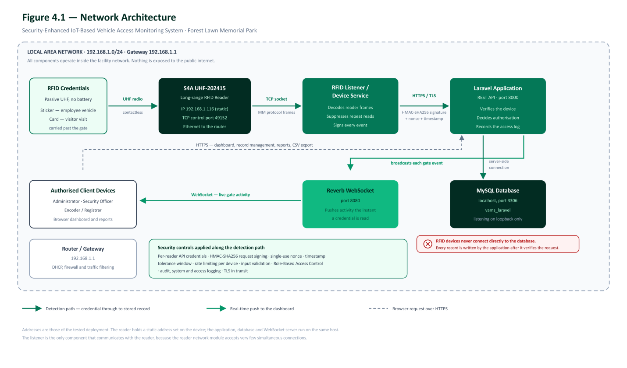
Figure 4.1. Network architecture of the Security-Enhanced IoT-Based Vehicle Access Monitoring System.

4.3 Application System Architecture

4.3.1 Overview
The system follows a layered architecture consisting of the presentation layer, application layer, API and business logic layer, data layer, and RFID device layer. Security and monitoring are cross-cutting concerns applied across the layers.

4.3.2 Components
The application is organized into layers so that each concern is handled in one place. The separation allows the user interface, the authorization rules, the device communication, and the stored records to be developed and tested independently, and it prevents device-facing code from reaching directly into the database.
Layer | Components and Functions
Presentation Layer | Administrator, Security Officer, Encoder/Registrar; dashboard, monitoring, management, logs, and reports.
Application Layer | Laravel/PHP, Blade, Tailwind CSS, JavaScript/AJAX, authentication, sessions, CRUD, reports, and user interfaces.
API and Business Logic Layer | REST API, device authentication, RFID detection processing, validation, authorization, entry/exit logic, RBAC, rate limiting, audit logging, and error handling.
Data Layer | MySQL tables for users, roles, employees, visitors, vehicles, RFID credentials, visits, readers, detections, access logs, audit logs, system logs, and settings.
RFID Device Layer | S4A UHF-202415 reader, RFID Listener/Device Service, permanent employee stickers, and temporary visitor RFID cards.

The presentation layer serves three user roles. The Administrator role holds full access, including user account management, system settings, and the deletion of operational records. The Security Officer role is limited to monitoring the gate and viewing records. The Encoder/Registrar role can view, create, and update employee, visitor, visitor visit, vehicle, RFID tag, RFID assignment, and RFID reader records, but cannot delete any of them; deletion of these records, together with user accounts and system settings, is restricted to the Administrator role. Every function in the interface is shown or hidden according to the permissions granted to the signed-in role, and the same permissions are enforced again on the server so that hiding a control in the interface is never the only protection.
The application programming interface layer is the boundary crossed by the RFID Listener/Device Service. Requests arriving at this boundary are rate limited, authenticated using device credentials, checked for replay, validated for structure, and only then processed into monitoring records. This ordering is deliberate: inexpensive checks are applied before expensive ones, so that a flood of invalid requests is rejected before the system performs signature verification or database lookups.

4.3.3 Application Architecture Diagram
The diagram illustrates the interaction among the presentation, application, API and business logic, database, and RFID device layers, including the security and monitoring controls applied throughout the system.

4.4 Data Flow Diagram

4.4.1 Overview
The data flow diagram shows how RFID data moves from physical detection to validation, access processing, storage, and presentation. It also shows the relationship between users, the application, RFID devices, and the system data stores.

4.4.2 Data Flow Process
1) Capture RFID Data â€” receive RFID detections from the S4A UHF-202415 reader through the RFID Listener/Device Service.
2) Validate and Authenticate â€” authenticate the device, validate the request, identify the credential, and check its status.
3) Process Access â€” apply access rules, determine employee or visitor status, determine entry or exit, and generate an access decision.
4) Store Data â€” save raw detections, access transactions, vehicle/visit status, audit logs, and system logs.
5) Present Information â€” display the current status, recent events, reports, and security information to authorized users.

4.4.3 Data Stores
Data Store | Stored Information
D1 Users and Roles | User accounts, roles, and permissions.
D2 Vehicles and RFID Credentials | Vehicles, RFID tags, and assignment history.
D3 Access Logs and Visits | Access transactions, visitor visits, and raw RFID detections.
D4 Audit Logs | User actions and security-relevant activities.
D5 System Logs and Settings | System errors, device events, and configuration values.

4.5 Security Framework

4.5.1 Overview
The security framework applies multiple layers of protection to the proposed system. The layers cover RFID data collection, network security, application and access control, data storage, security monitoring and response, and security testing. The framework is designed so that failure of one control does not automatically result in unrestricted access to the system.

4.5.2 Security Mechanisms
Area | Security Mechanisms
Network Security | HTTPS/TLS, firewall and LAN restrictions, traffic filtering, network monitoring.
Device Security | Unique device authentication, registered-device checking, heartbeat and device status monitoring.
Application Security | User authentication, RBAC, session management, input validation, rate limiting.
RFID Security | Credential status validation, assignment checking, denial of unknown/inactive/expired credentials, duplicate detection handling.
Data Security | Password hashing, database constraints, restricted access, backups, validation, audit logging.
Monitoring and Response | Real-time monitoring, security alerts, audit logs, system logs, and incident review.
Security Testing | Authorized network scanning, packet analysis, controlled security assessment, and load testing.

4.5.3 Security Framework Diagram
The diagram presents the security controls applied to the IoT, network, application, data, monitoring, and testing layers. It also relates the controls to confidentiality, integrity, and availability.

4.6 RFID Device Development

4.6.1 Overview
The RFID device component consists of the S4A UHF-202415 reader and the RFID Listener/Device Service. The reader detects passive UHF RFID credentials. The device service runs on a Windows PC or mini-PC and uses the vendor-supplied reader interface to receive RFID events and forward them to the Laravel API.

4.6.2 Functionality
ï‚· Connect to the S4A UHF-202415 reader.
ï‚· Receive RFID EPC detections and available antenna or signal information.
ï‚· Normalize RFID events.
ï‚· Apply an initial configurable duplicate/debounce filter.
ï‚· Generate a unique event identifier.
ï‚· Authenticate with the Laravel API.
ï‚· Send RFID detection events to the application.
ï‚· Send periodic heartbeat information.
ï‚· Reconnect after reader or network interruption.
ï‚· Record local service errors and connection events.
ï‚· Optionally buffer events temporarily when the application is unavailable.
The RFID Listener/Device Service does not determine whether a vehicle is authorized. Authorization remains in the Laravel application so that employee, visitor, vehicle, RFID, and visit rules remain centralized.

4.6.3 Reader Connectivity and API Validation
Prior to development of the RFID Listener/Device Service, the physical S4A UHF-202415 reader and the Laravel API ingestion endpoint were validated independently to confirm end-to-end feasibility. The reader was connected over Ethernet/TCP-IP at a fixed network address and accessed using the vendor-supplied RFIDDemo test utility, which confirmed that the reader could establish a TCP session on its control port and return Electronic Product Code (EPC) values for tags placed within read range.
The Laravel API endpoint (POST /api/rfid/detections) was validated separately using a PowerShell script that reproduces the request format expected from the RFID Listener/Device Service: an HMAC-SHA256 signature computed over the API key, timestamp, nonce, and request body, transmitted through the X-Rfid-Api-Key, X-Rfid-Timestamp, X-Rfid-Nonce, and X-Rfid-Signature headers. This test confirmed that the endpoint correctly rejects detections from unregistered credentials, accepts and authorizes detections from registered and assigned RFID credentials, applies a five-second debounce window to suppress duplicate detections, and rejects replayed requests using an expired or reused nonce.
These two validations established that the reader hardware, network path, and API security controls function as designed before the RFID Listener/Device Service was implemented, reducing integration risk for the remaining development work.

4.7 Security Testing and Evaluation

4.7.1 Tools Used
Tool | Purpose
Wireshark | Authorized packet capture and traffic analysis to verify communication behavior.
Nmap | Authorized network scanning to identify exposed ports and services.
Metasploit | Controlled security assessment of applicable services in an authorized environment.
Apache JMeter | Controlled load and flooding-resistance testing.

4.7.2 Testing Procedure
ï‚· Verify authentication and authorization behavior.
ï‚· Perform authorized network scanning.
ï‚· Capture and analyze authorized network packets.
ï‚· Verify that protected application communication uses TLS.
ï‚· Submit invalid device credentials and verify rejection.
ï‚· Submit malformed requests and verify server-side validation.
ï‚· Test unauthorized functions and verify RBAC enforcement.
ï‚· Simulate controlled excessive requests using Apache JMeter.
ï‚· Verify that rate limiting responds to excessive traffic.
ï‚· Check audit logs and system/error logs.
ï‚· Evaluate system stability and service recovery under controlled conditions.

4.7.3 Metrics
ï‚· Accuracy
ï‚· Security
ï‚· Audit Logging
ï‚· Error Detection
ï‚· Response Time
ï‚· Flooding Resistance
ï‚· Reliability
ï‚· RFID Detection Consistency

4.8 Security Design Considerations
ï‚· Accuracy â€” ensures that RFID detections and access records correspond to actual vehicle movements.
ï‚· Integrity â€” prevents unauthorized changes to vehicle, RFID, visitor, and access records.
ï‚· Confidentiality â€” protects sensitive information through authentication, authorization, and encrypted communication.
ï‚· Availability â€” supports continued service operation through monitoring, reconnection, backups, and controlled traffic.
ï‚· Auditability â€” tracks important user, device, and system activities.
ï‚· Least Privilege â€” limits user and device permissions to required functions.
ï‚· Defense in Depth â€” combines network, device, application, database, monitoring, and testing controls.
ï‚· Error Handling â€” records failures without exposing sensitive technical details to unauthorized users.

4.9 Prototype Implementation and System Interface
This section presents the working prototype of the Security-Enhanced IoT-Based Vehicle Access Monitoring System as implemented for Forest Lawn Memorial Park. The screens were captured from the running web application while signed in as the Administrator, so every module is visible; a Security Officer or an Encoder/Registrar sees only the modules that the role permits. The records shown are test data entered during development and testing.

4.9.1 Authentication and Access Control
Access to the web application begins with sign-in and is then limited by the role assigned to each account.
Figure 4.9.1
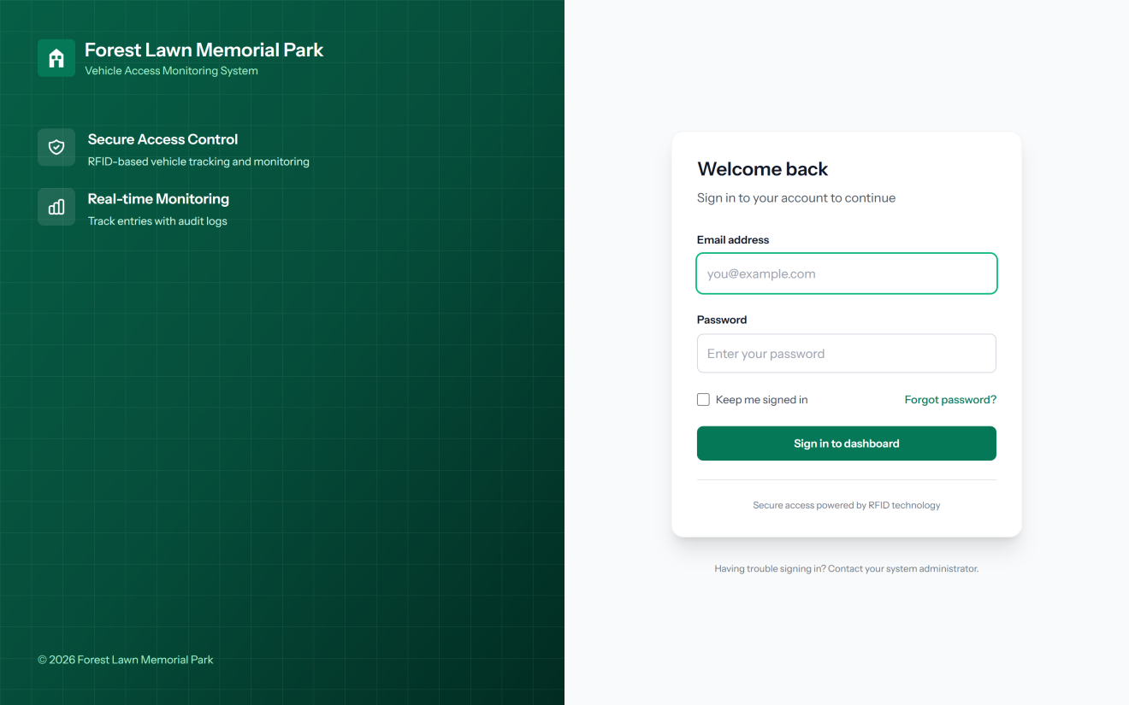
Login Page
Figure 4.9.1 presents the login page, the only page of the web application that can be opened without signing in. Every user must enter a registered email address and password before any record can be viewed. Sign-in attempts are limited per minute to slow down password-guessing attacks, and an account that has been suspended or locked is refused even when the correct password is entered.
Figure 4.9.2
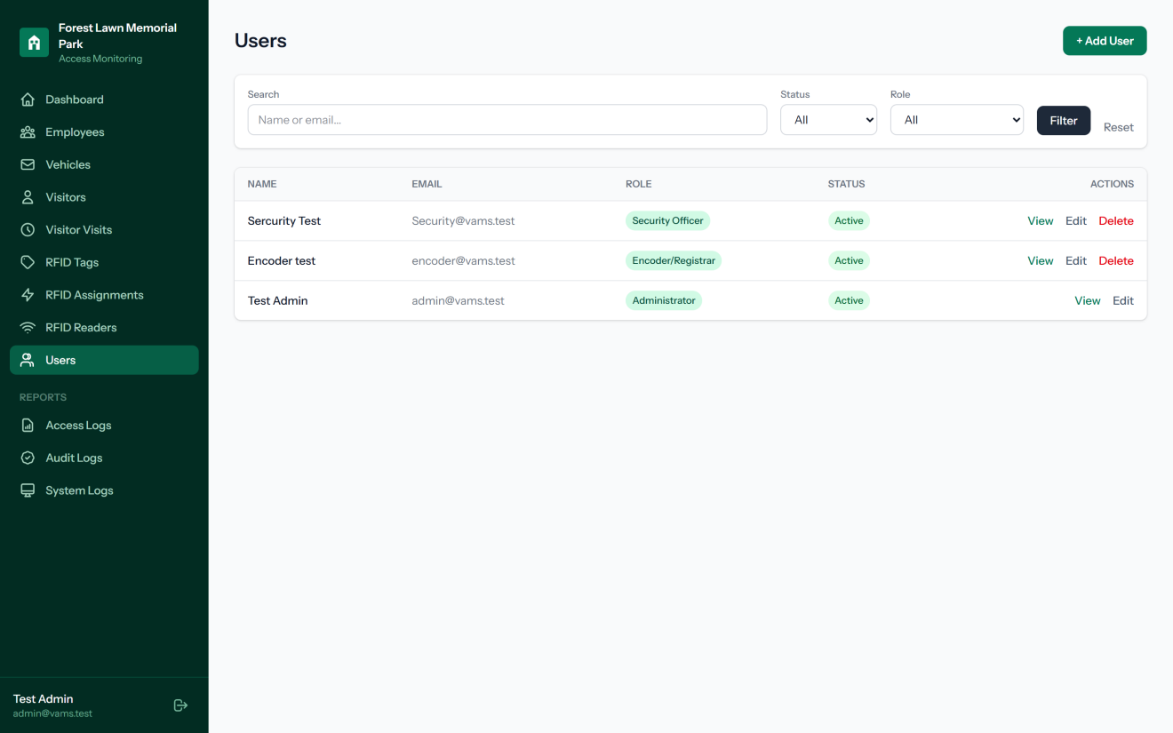
User Account and Role Management
Figure 4.9.2 presents the user management module, which is available only to the Administrator. Each account is given one of three roles, namely Administrator, Security Officer, or Encoder/Registrar, and the role decides which menu items and actions the user can reach. The signed-in Administrator cannot delete their own account, which prevents the system from being left without an administrator.

4.9.2 Gate Activity Monitoring
The monitoring pages replace the paper logbook that the guards previously kept at the gate.
Figure 4.9.3
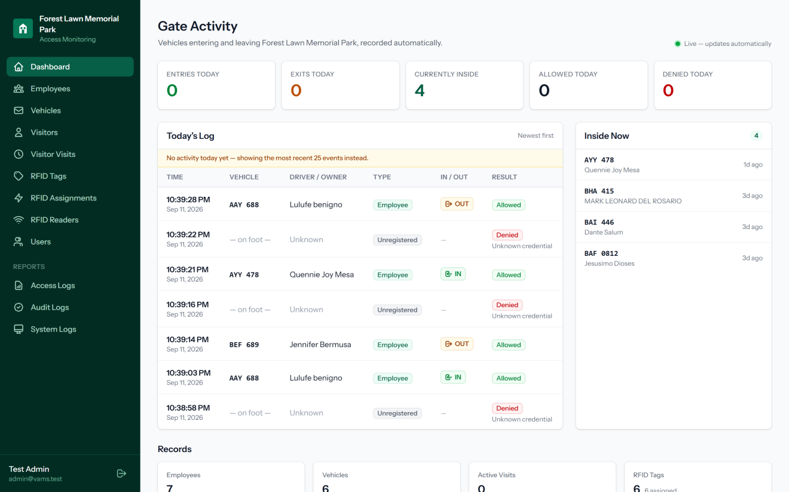
Gate Activity Dashboard
Figure 4.9.3 presents the Gate Activity dashboard, the first page shown after signing in. Each time a registered RFID sticker passes the reader, the entry or exit is added to Today's Log together with the time, plate number, driver or owner, owner type, direction, and result. The cards across the top count the entries, exits, allowed reads, and denied reads for the day and the number of vehicles currently inside, while the Inside Now panel lists those vehicles by plate number. The page is updated instantly through a WebSocket connection, so the guard sees a vehicle enter without refreshing the page. When there is no activity yet for the day, as in this capture, the log shows the most recent events instead.
Figure 4.9.4
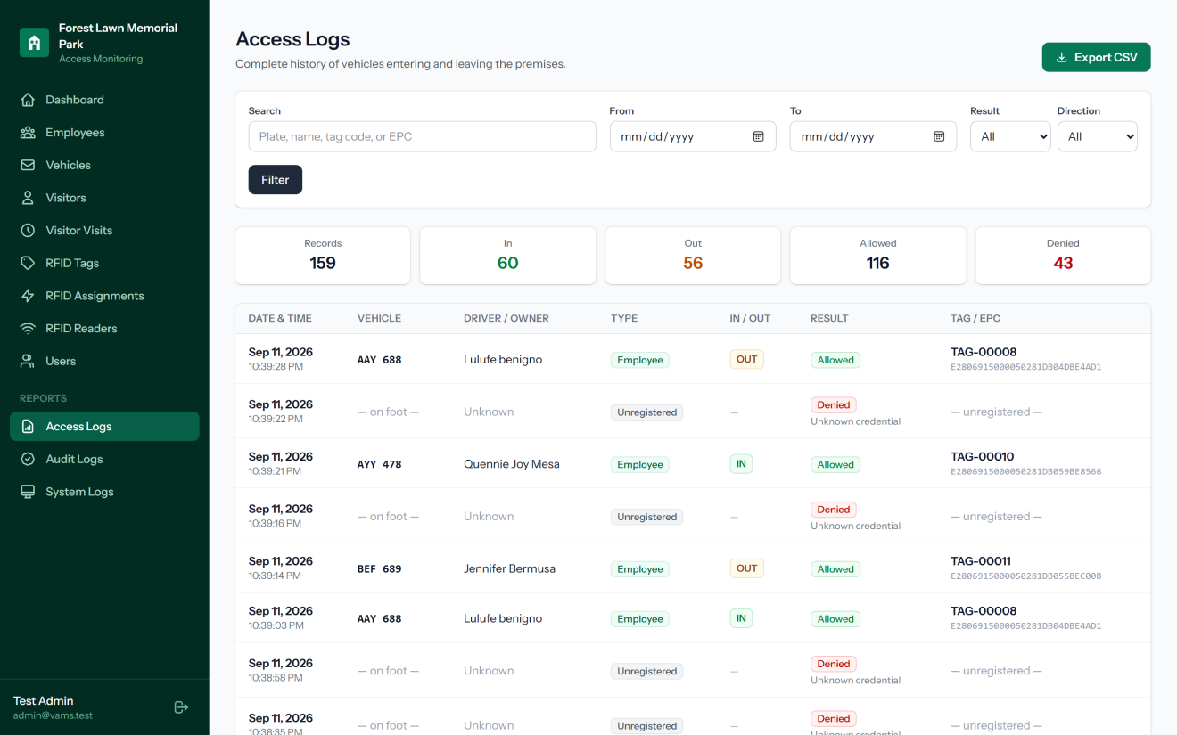
Access Log Report
Figure 4.9.4 presents the Access Logs report, the complete history of every vehicle movement recorded at the gate. Records can be searched by plate number, name, tag code, or EPC and filtered by date range, result, and direction. The summary cards show how many records, entries, exits, allowed reads, and denied reads match the filter, and the Export CSV button downloads the filtered records for reporting. Denied reads, such as unregistered credentials, are kept together with allowed reads so that failed attempts can also be reviewed.

4.9.3 Records Management
The Encoder/Registrar maintains the employee, vehicle, and visitor records against which every RFID read is checked.
Figure 4.9.5
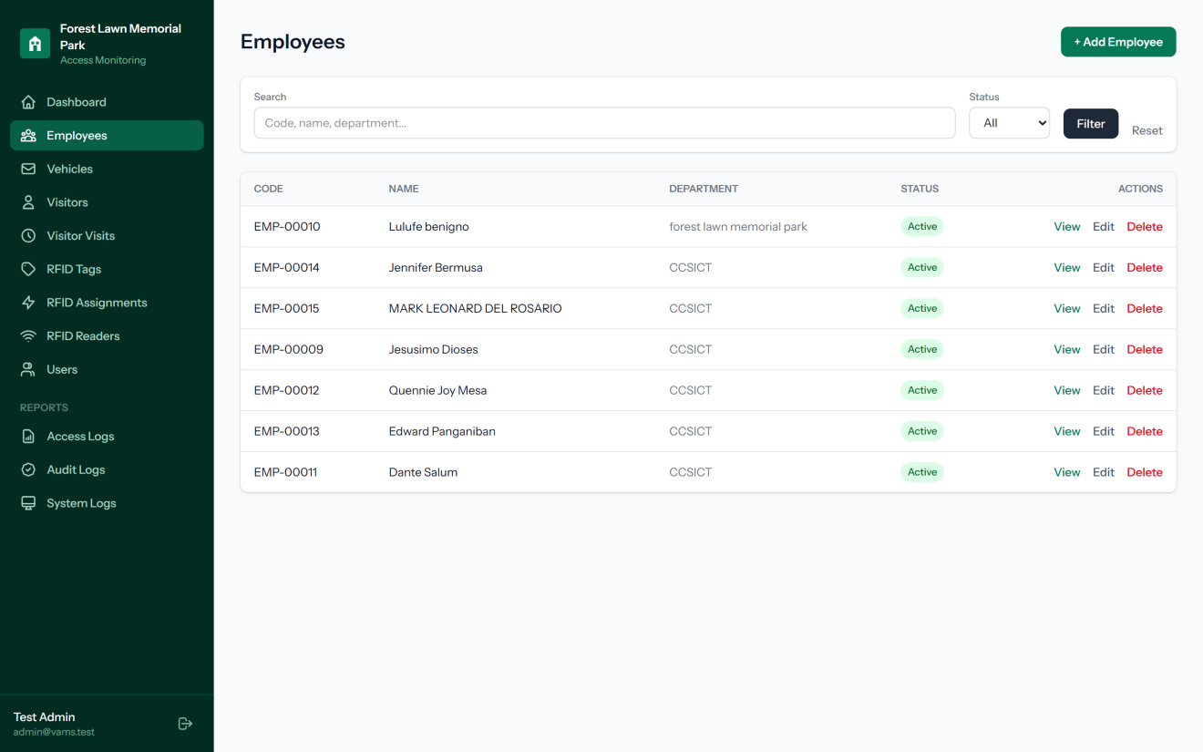
Employee Records
Figure 4.9.5 presents the employee records module, where the employees whose vehicles are permitted to enter the premises are registered. Each employee receives a unique employee code, and the list can be searched by code, name, or department and filtered by status.
Figure 4.9.6
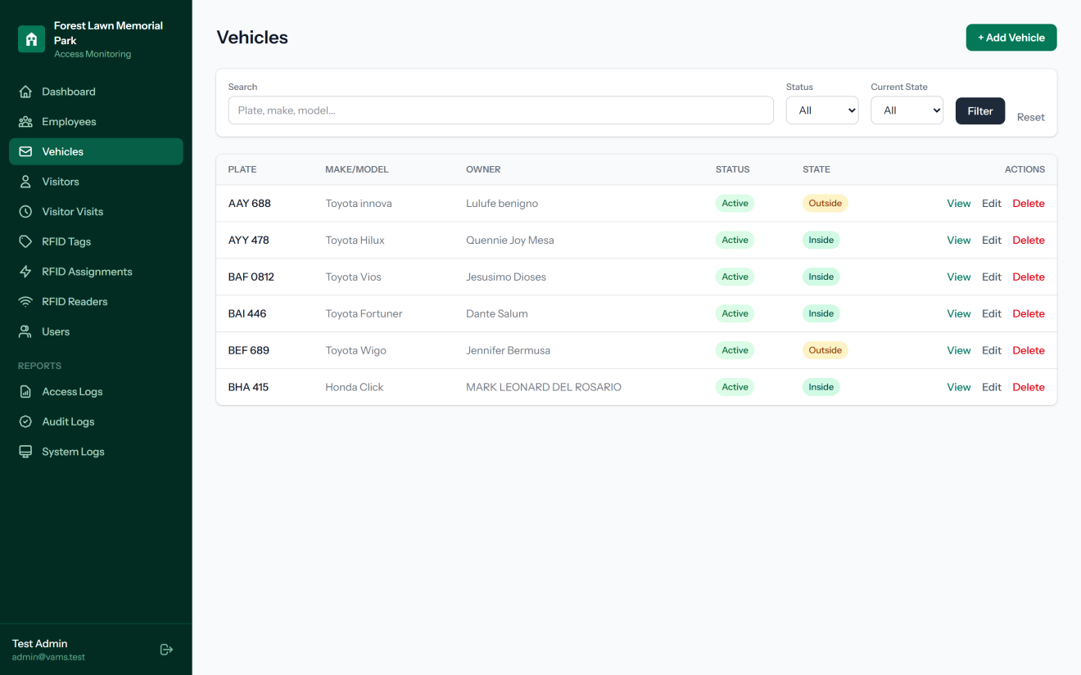
Vehicle Records
Figure 4.9.6 presents the vehicle records module. Each vehicle is listed with its plate number, make and model, owner, registration status, and current state. The current state, Inside or Outside, is updated automatically by the gate reads, so the office can tell at a glance which vehicles are still within the premises.
Figure 4.9.7
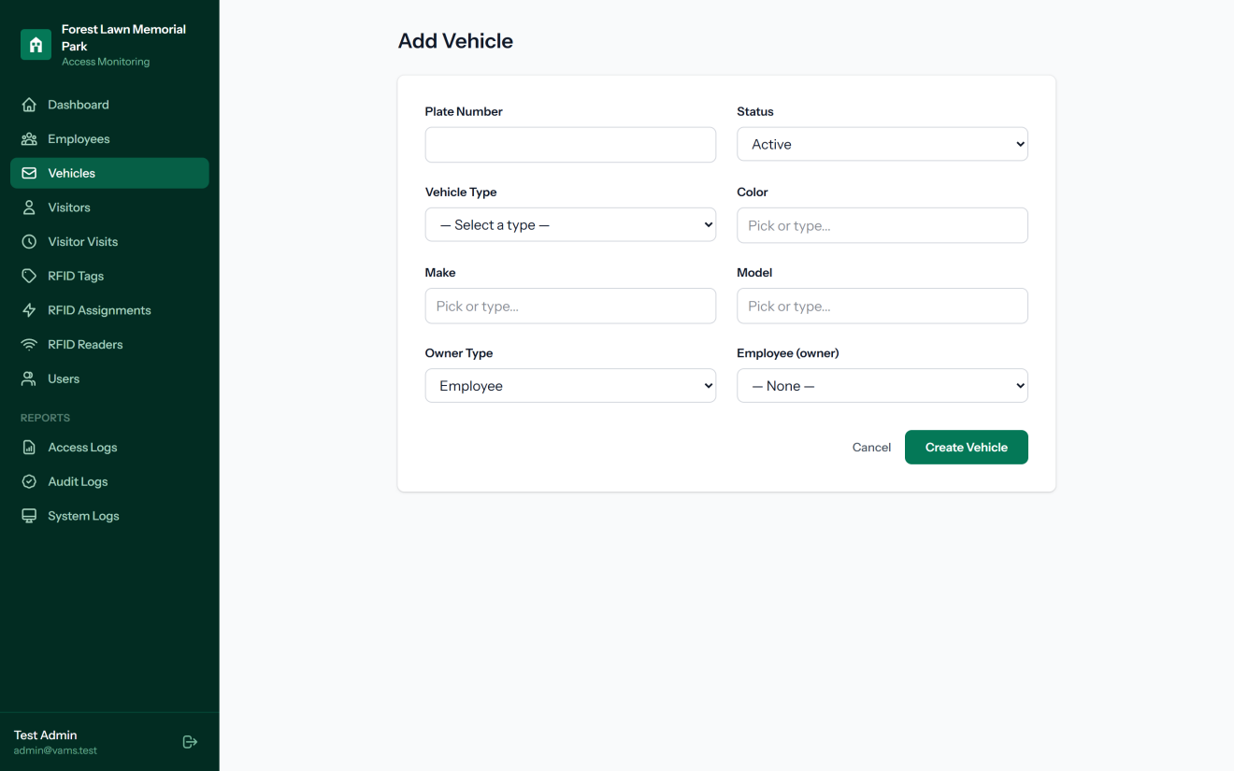
Vehicle Registration Form
Figure 4.9.7 presents the vehicle registration form. To make encoding faster and more consistent, the vehicle type is chosen from a fixed list, while the color, make, and model fields offer common choices that can still be typed over, and the model suggestions narrow down to the selected make. The owner is chosen from the registered employees, which links the vehicle to a person in the gate log.
Figure 4.9.8
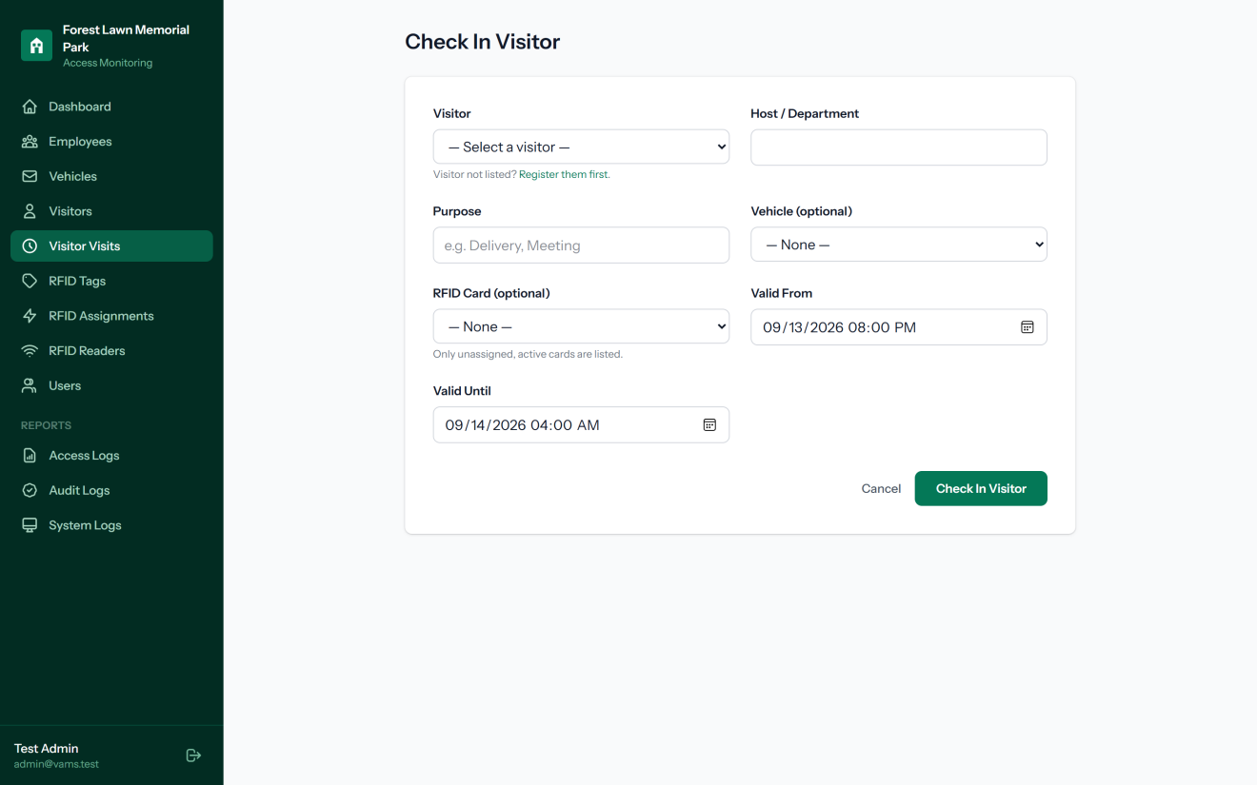
Visitor Check-In Form
Figure 4.9.8 presents the visitor check-in form, which is used when a visitor arrives at the gate. The guard selects a registered visitor, records the purpose of the visit and the host or department, and may attach a vehicle and a temporary RFID card. The Valid From and Valid Until fields limit the period during which the visit is valid, and only cards that are active and not already in use are offered.

4.9.4 RFID Credential Management
These modules manage the RFID stickers and cards, the vehicles and visits they are attached to, and the reader that detects them.
Figure 4.9.9
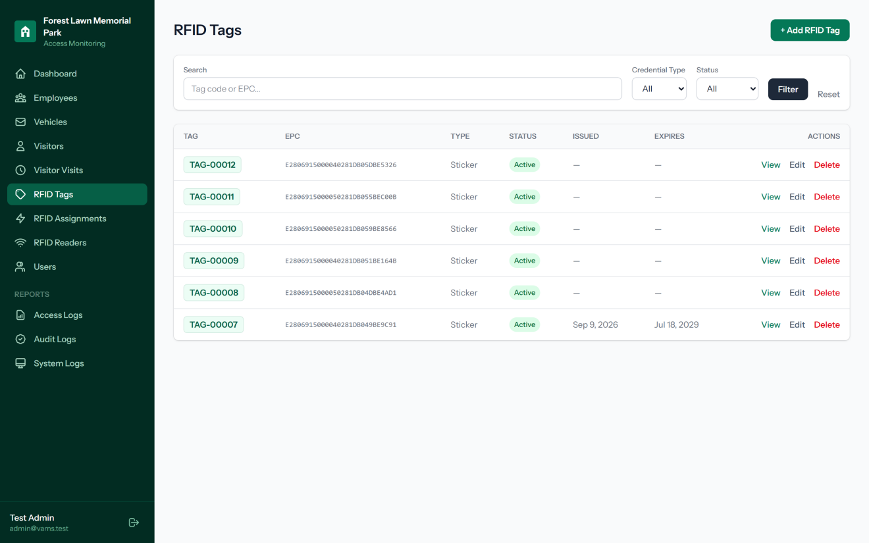
RFID Tag Inventory
Figure 4.9.9 presents the RFID tag inventory. Every sticker or card is given a short, readable tag code, such as TAG-00012, displayed beside its long EPC number, so that staff can match a physical sticker to its record without reading the full EPC. Each tag also has a credential type, a status such as Active, Lost, or Disabled, and optional issue and expiry dates.
Figure 4.9.10
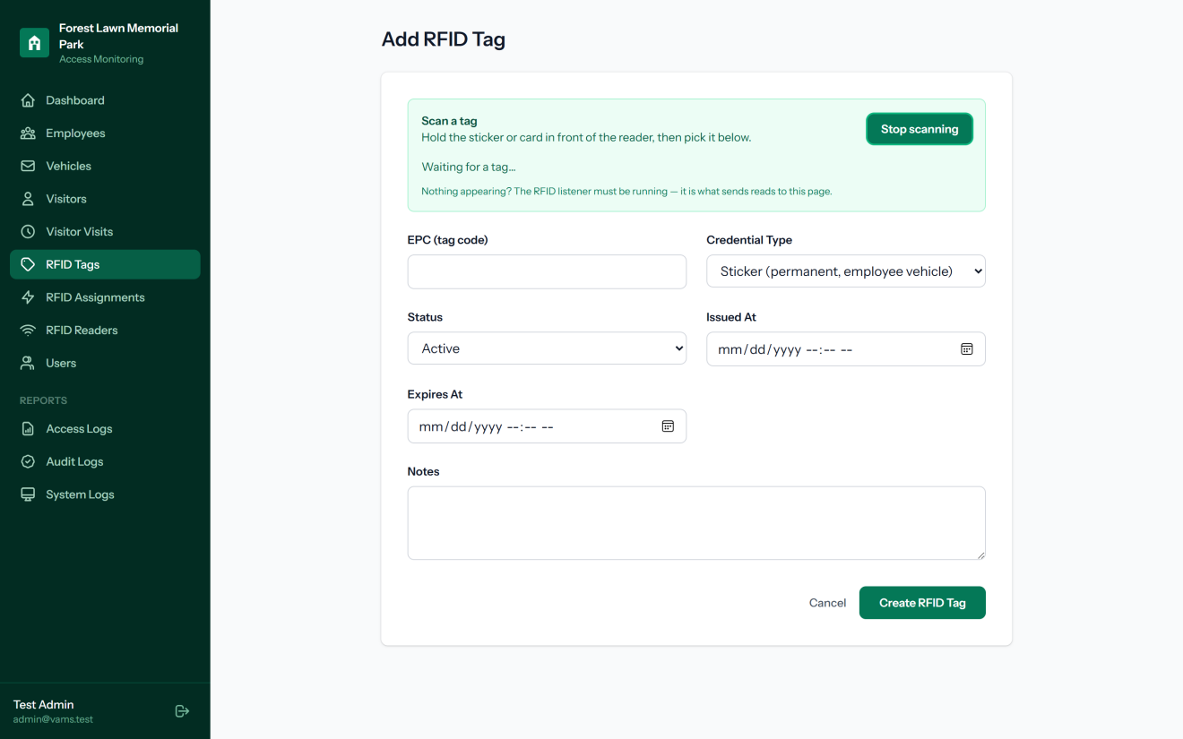
RFID Tag Registration with Scan Helper
Figure 4.9.10 presents the RFID tag registration form with its scan helper. Instead of copying the EPC by hand, the staff member presses Start scanning and holds the new sticker or card in front of the reader; the tags detected by the reader appear in the panel and can be selected to fill in the EPC field automatically. This reduces encoding errors and allows non-technical staff to register tags.
Figure 4.9.11
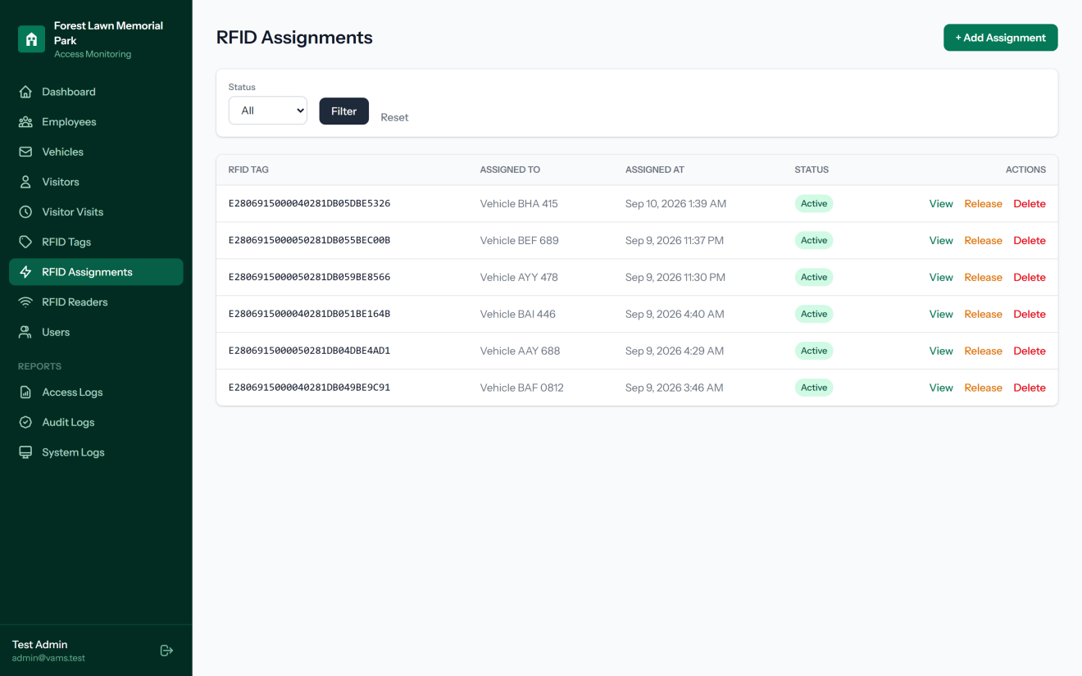
RFID Tag Assignments
Figure 4.9.11 presents the RFID assignments module, which records which tag is attached to which vehicle or visitor visit and since when. An assignment is released when a sticker is removed or a card is returned, which frees the tag for reuse while keeping the record of who held it.
Figure 4.9.12
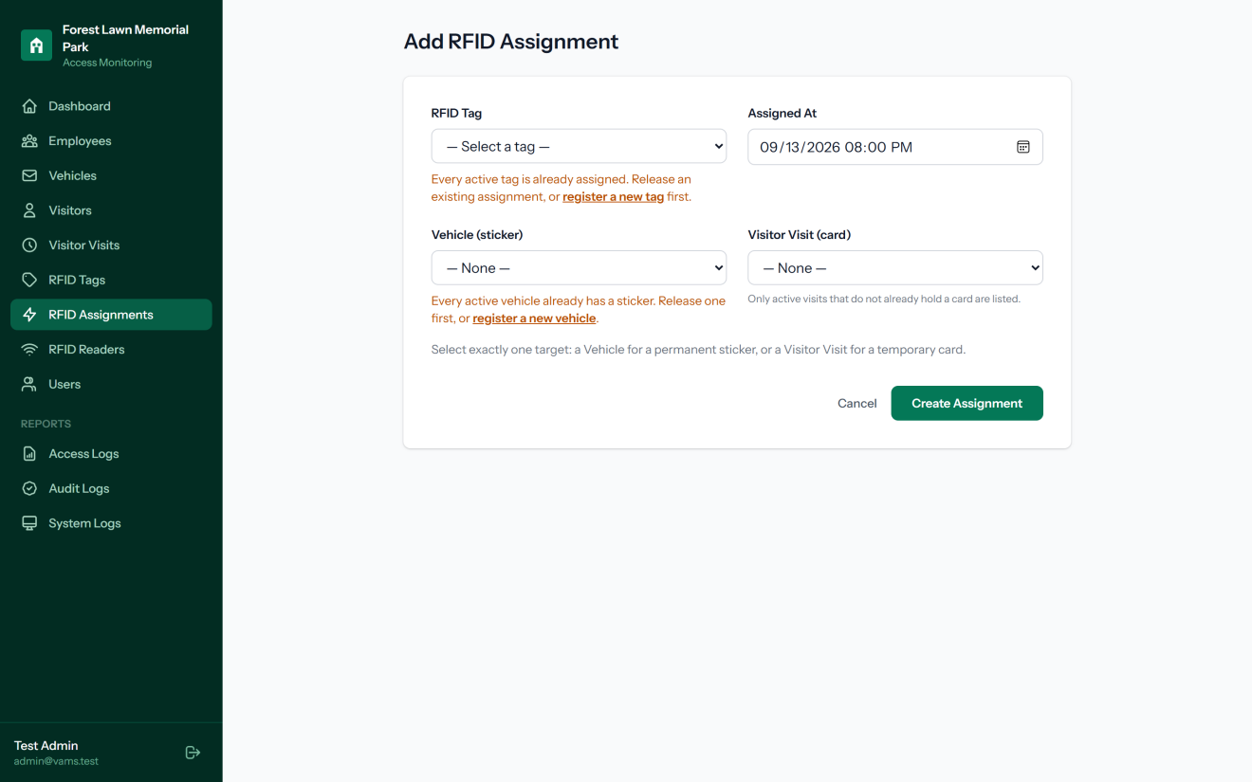
RFID Assignment Form
Figure 4.9.12 presents the form for assigning an RFID tag. Only active tags that are not already assigned, and only vehicles or visits that do not already hold a credential, are listed, which prevents one tag from being given to two vehicles and one vehicle from receiving two stickers. Exactly one target must be selected: a vehicle for a permanent sticker or a visitor visit for a temporary card. In this capture every tag and vehicle is already assigned, so the form explains what to do next instead.
Figure 4.9.13
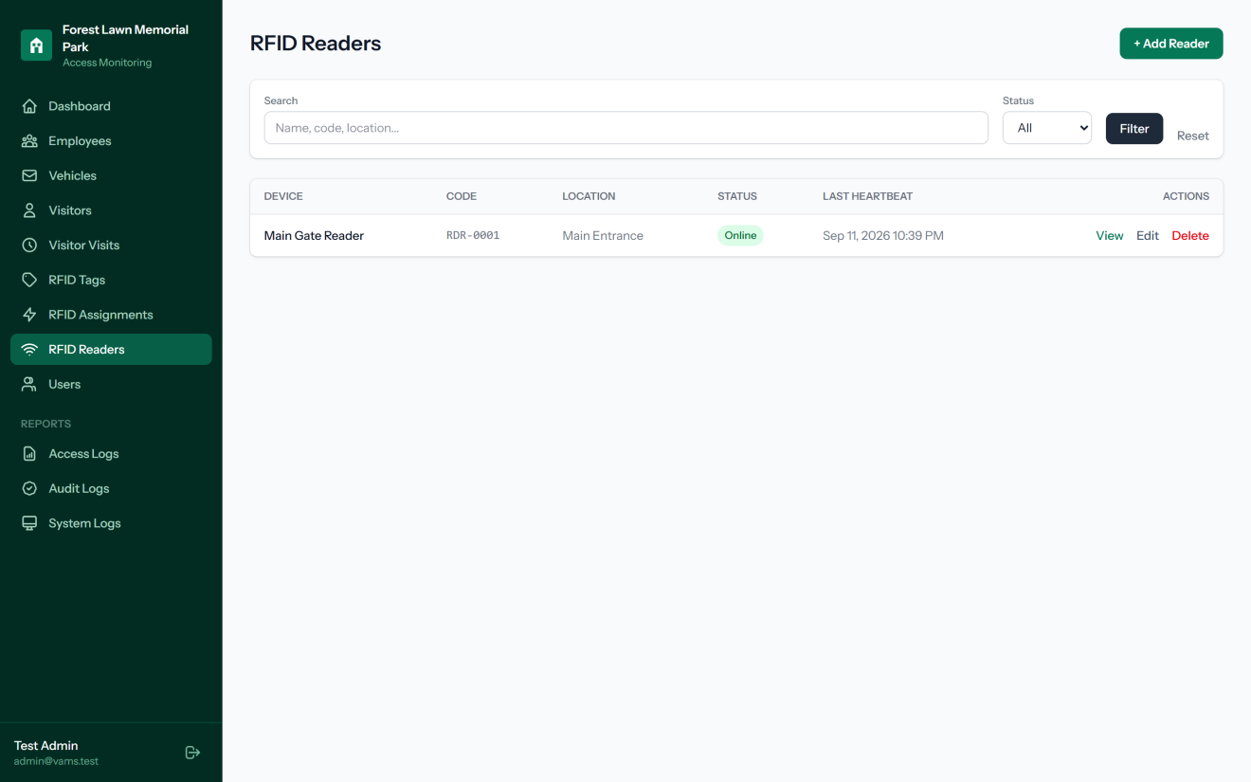
RFID Reader Registry
Figure 4.9.13 presents the RFID reader registry, which lists the S4A UHF-202415 reader installed at the main entrance with its code, location, status, and last heartbeat. Each registered reader is issued its own API key and secret, which the RFID listener uses to sign every request it sends to the web application with HMAC-SHA256. Requests without a valid signature, with a reused nonce, or with a timestamp outside the allowed window are rejected. The page that displays these credentials was deliberately not captured for this manuscript.

4.9.5 Audit and System Logging
Two separate logs support accountability: one for changes made by users and one for events raised by the devices and the application.
Figure 4.9.14
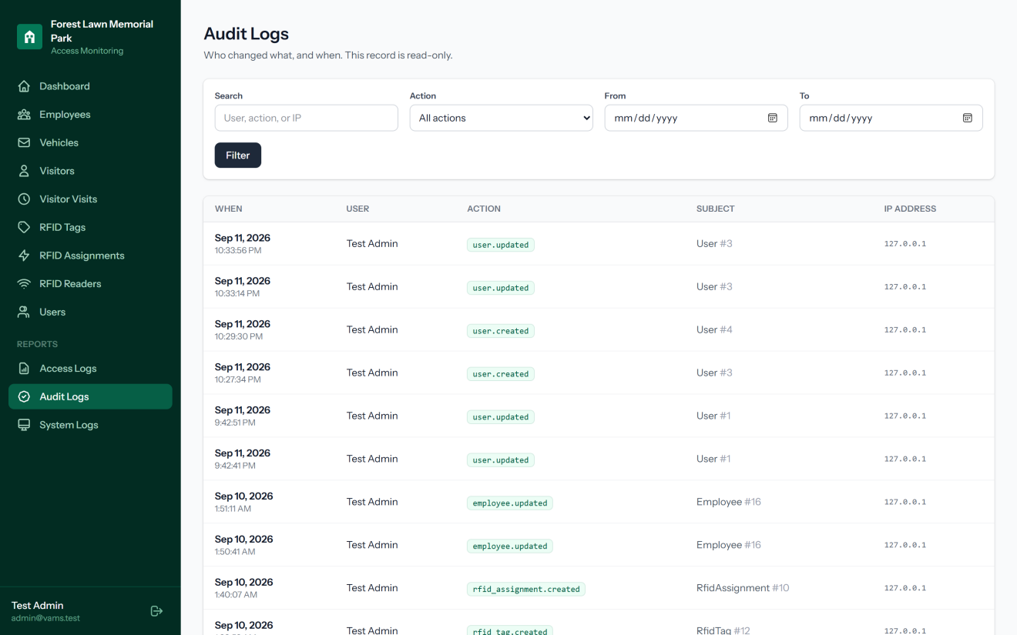
Audit Log
Figure 4.9.14 presents the audit log, a read-only record of changes made through the web application. Each entry shows when the change happened, the user who made it, the action performed, such as user.updated or rfid_assignment.created, the affected record, and the IP address of the request. Because the interface provides no way to edit or delete these entries, the audit log supports accountability and helps in investigating unauthorized changes.
Figure 4.9.15
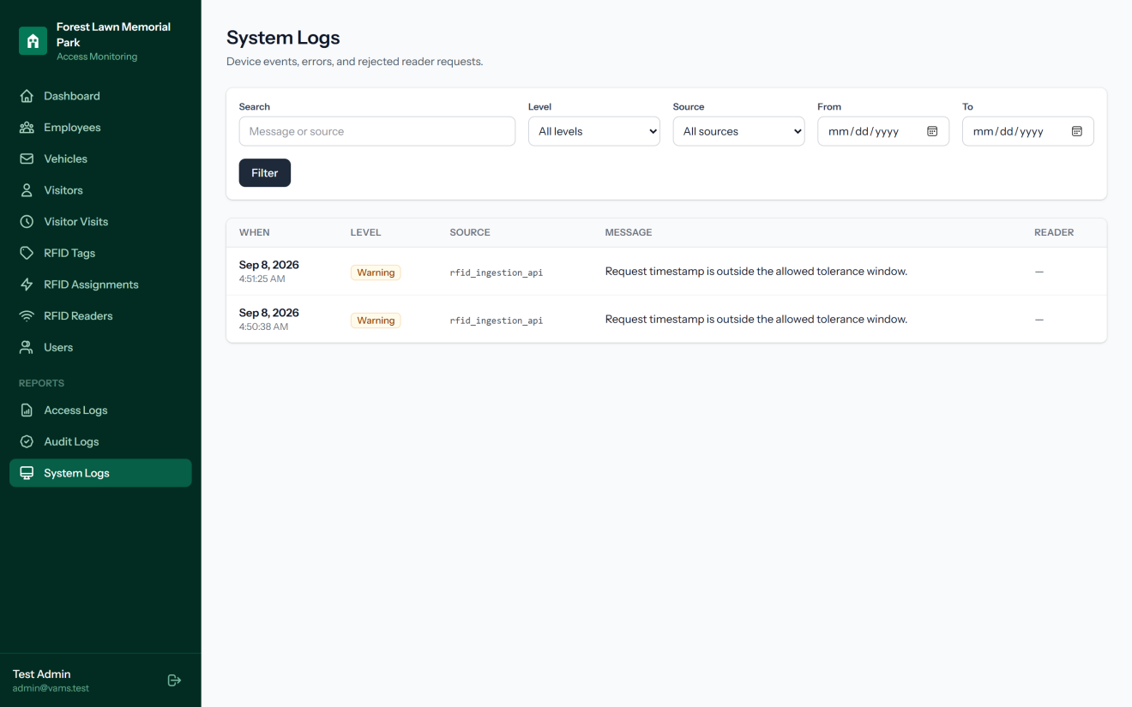
System Log
Figure 4.9.15 presents the system log, which records device events, errors, and rejected reader requests. Each entry shows its level, source, message, and the reader involved, and the list can be filtered by level, source, and date. The entries shown are warnings from the RFID ingestion API rejecting requests whose timestamp was outside the allowed tolerance window, which shows the replay protection working as designed. Requests that exceed the rate limit are also recorded here.

4.10 Summary
This chapter presented the updated system architecture, network design, application structure, data flow, RFID device service, and security framework of the proposed system. The design uses the S4A UHF-202415 RFID reader, RFID Listener/Device Service, Laravel/PHP, and MySQL. Employee vehicles use permanent RFID stickers, while visitors use temporary RFID cards. The system applies authentication, RBAC, TLS, input validation, rate limiting, logging, and database controls to improve security, traceability, and reliability.
The following figures summarize the proposed security framework, data flow, and application architecture.
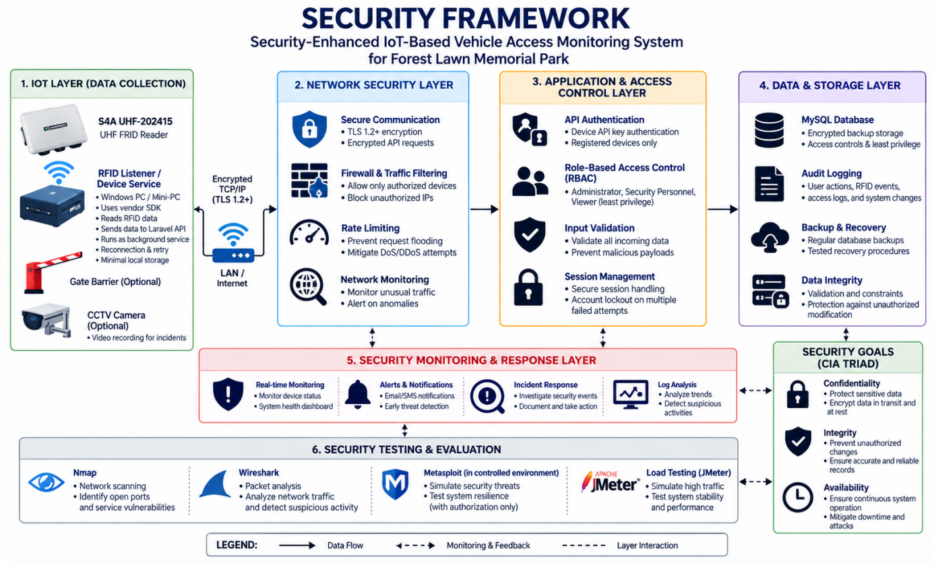
Figure 4.10.1
Security Framework Diagram
The diagram shows how the security controls protect the proposed system through IoT, network, application, data, monitoring, and testing layers.
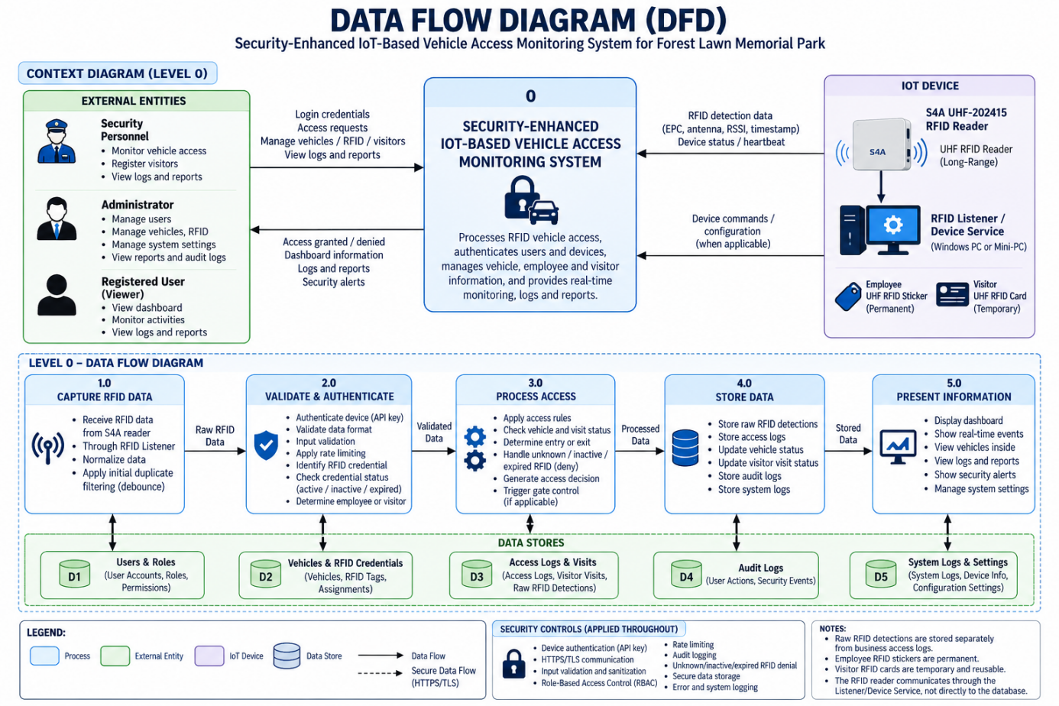
Figure 4.10.2
Data Flow Diagram
The diagram shows how RFID data moves from the S4A UHF-202415 reader through the RFID Listener/Device Service to validation, access processing, storage, and presentation.
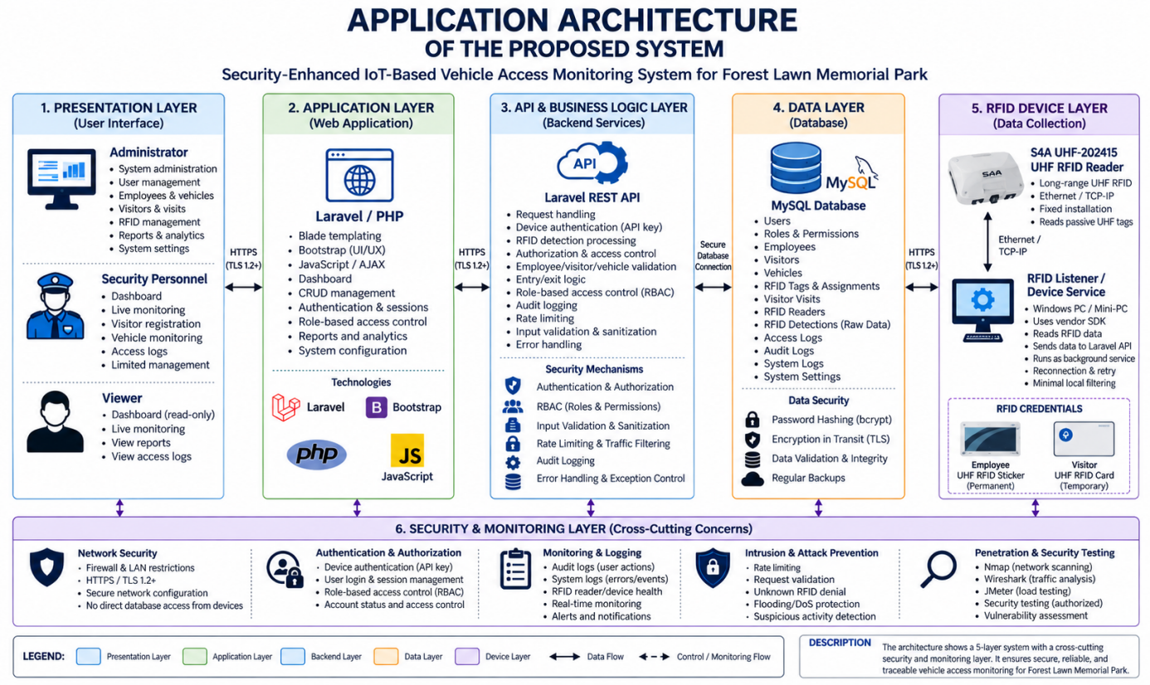
Figure 4.10.3
Application Architecture Diagram
The diagram shows the interaction between the presentation, application, API and business logic, data, and RFID device layers, including the security and monitoring controls.
Figure 4.10.4
Network Architecture Diagram
The network architecture shows the S4A UHF-202415 reader connected to the RFID Listener/Device Service through Ethernet/TCP-IP, with protected communication to the Laravel application and controlled server-side access to the MySQL database.

References
BaraÃ±ao, J. P. (2024). RFID-based monitoring system with SMS notification for institutional facilities. Philippine Journal of Information Systems, 10(1), 15â€“22.
Domingo, R. L. (2024). Face recognition-based monitoring system for facility access control. Philippine Journal of Information Technology, 9(1), 45â€“52.
Evangelista, M. A., Cruz, P. R., & Lopez, J. D. (2025). QR code-based monitoring system using cloud database integration. Journal of Emerging Technologies, 12(2), 78â€“85.
Fadlianda, R., Putra, A., & Hidayat, T. (2024). IoT-based automated monitoring systems using RFID technology. International Journal of Advanced Computer Science, 15(3), 101â€“110.
Garcia, L. M., & Santos, R. T. (2023). Web-based monitoring platform for real-time system tracking. Philippine Computing Journal, 8(2), 60â€“68.
Ishaq, M., & Bibi, S. (2023). A systematic review of IoT-based monitoring systems. Journal of Network and Computer Applications, 210, 103115.
ISO. (2022). ISO/IEC 27001: Information security management systems requirements. International Organization for Standardization.
ISO/IEC. (2011). Systems and software engineeringâ€”Systems and software quality requirements and evaluation (SQuaRE): System and software quality models (ISO/IEC 25010). International Organization for Standardization.
Kavitha, R., Kumar, S., & Devi, P. (2023). RFID-based vehicle monitoring system for secure facility access. International Journal of Engineering Research and Technology, 12(4), 233â€“240.
Masri, H., & Aziz, N. (2025). Automated vehicle access monitoring using RFID technology. Journal of Smart Systems, 18(1), 12â€“20.
Nurhadryani, Y., Prasetyo, E., & Wibowo, A. (2022). Evaluation of manual and automated monitoring systems. Journal of Information Systems, 16(2), 89â€“97.
Ranjani, P., Kumar, V., & Sharma, D. (2024). IoT-based monitoring systems for real-time data transmission. International Journal of Internet of Things, 13(1), 55â€“63.
Salfian, M. (2025). RFID technology for automated identification systems. Journal of Wireless Communication, 19(2), 34â€“42.
Shrivastava, A., Patel, R., & Singh, K. (2023). Cloud-integrated IoT RFID monitoring systems. International Journal of Cloud Computing, 11(3), 144â€“152.
Soma, R., Lee, J., & Park, H. (2022). IoT-based RFID toll collection and monitoring system. IEEE Access, 10, 56789â€“56798.
Tran, Q., Nguyen, T., & Pham, L. (2022). Long-range RFID monitoring with camera verification. Sensors, 22(14), 5432.
Velasco, M. D. (2023). RFID-based entry monitoring system for institutions. Philippine Journal of Technology, 7(1), 22â€“29.
Whitman, M. E., & Mattord, H. J. (2021). Principles of information security (6th ed.). Cengage Learning.
Williams, J., Brown, T., & Davis, L. (2022). Security vulnerabilities in IoT systems. Cybersecurity Journal, 5(3), 120â€“130.

